**Variation of flower visitors between mango orchard and surrounding natural vegetation.**

**V. Simba**

# Abstract

The link between biodiversity in natural vegetation and the provision of these ecosystem services was investigated in *Mangifera indica* (Mango) orchards using a network approach. Flower visitor sampling surveys were carried out for six months (June to October 2013 and January 2014) on three farms in plots (25 × 3 m) at varying distances (1 m, 10 m, 50 m, 100 m and 200 m) from the edge with natural vegetation, both into the mango orchard and into the natural vegetation. Given that sampling was repeated at the three farms, for six months and in the same plots, generalized linear mixed models (GLMM) were used to assess the effect of distance, habitat and flower diversity on flower visitor. Flower visitor networks were analysed to investigate plant pollinator interactions and how these interactions change with distance in the two habitats. There were more flowering plant species in the natural vegetation (NV) than in the mango orchard, however, there were significantly more flowers within mango orchards that included a combination of agricultural weeds and the mango flowers themselves. Abundance of wild flower resources on farms was positively correlated with mango flower visitation. Plant diversity has a positive effect on flower visitors, maintaining native plant species within mango orchards may increase the diversity on mango flower visitors.

# Introduction

## Background

One of the major reasons why ecosystem services have risen as a motive for conservation biology is the global pollination crisis currently threatening agricultural productivity because of a decline in the abundance of animal pollinators (Kremen and Ricketts, 2000). There is a variety of agricultural crops, from those that are self-pollinating, to wind pollinated and those that rely heavily on animal pollination. However, in the last half-century there has been an increase in the fraction of agricultural crops that depend on animal pollination (Klein et al., 2007). The main concern now is that with the global demand, the rapid growth of cultivation of these pollinator-dependent crops has the potential to trigger future pollination problems for both the agricultural crops and the native species surrounding them (Aizen and Harder, 2009).

About 65% of plant species require pollination by animals and analysis of data from 200 countries shows that 75% of crop species of global significance for food production rely primarily on insects (Power, 2010). The dependence of agriculture on pollinators is said to be higher in the developing world (Aizen et al., 2008.). It has been estimated that the loss of pollinators could reduce total agricultural production by 3-8%, increasing the demand for agricultural land in the developing world, and contributing to global environment change (Aizen et al. 2009).

*Mangifera indica* is a tropical plant found in the order of the Spindales, family of the Anacardiaceae. It requires tropical climates at low altitudes and winter dry seasons for flowering and fruit set (Watson and Dallwitz, 1992). Mango flowers are born on terminal inflorescences that are broadly conical; the inflorescences bear hundreds of flowers. They have two forms of flowers occurring in the inflorescences, male and hermaphrodite (Bally, 2006).

## Aim

To assess the variation of flower visitors between mango orchard and surrounding natural vegetation.

## Research question

Do flower visitors vary between the mango orchard and the surrounding natural vegetation?

Is there an effect of distance from the edge (edge between the mango orchard and natural vegetation) on flower visitors?

Is the abundance and species richness of flower visitors influenced by the number of flowering plant species?

## Hypothesis

Null hypothesis: The number of flower visitors is the same between the mango orchard and the surrounding Natural vegetation

Alternative hypothesis: There is more flower visitor in mango orchards than the surrounding natural vegetation

# Material and methods

## Study area and design

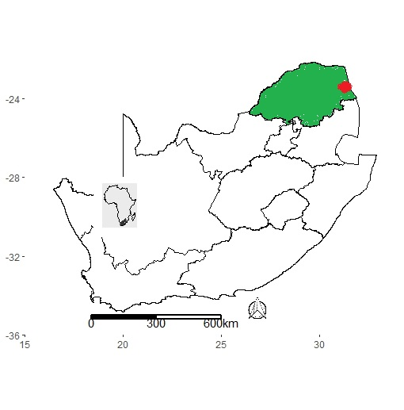

This study was conducted on three farms (Bavaria, Mohlatsi and Venden) near Hoedspruit (Maruleng municipality) within the Kruger to Canyons Biosphere, Limpopo Province, South Africa (24° 24′58.44” S and 30° 52′35.13” E). Bavaria and Venden are situated along the R527 road, west of Hoedspruit, 6.8 km away from each other, while Mohlatsi is 21.4 km south-west and 14.8 km south of Bavaria and Venden, respectively. On each farm, rows of windbreak trees (Casuarina sp.) divide the blocks of mango trees (∼70 ×150m). Blocks contain a single cultivar, and we sampled blocks containing Kent, Tommy Atkins, Sensation and Suzie. At each farm, we established transects, at least 250 m apart, which ran perpendicular to the edge between the natural vegetation and mango fields. Transects were composed of 10 plots (25 m x 3 m) that ran parallel to the edge between mango fields and the natural vegetation at distances of 200 m, 100 m, 50 m, 10 m and 1 m from the edge between the two habitats, into each habitat type (i.e., mango or natural vegetation). There were four such transects in Bavaria and three each in Mohlatsi and Venden.

## Sampling

The interaction between flower visitors and flower was assessed in June-October 2013.

Plots in each transect were assessed once a month with an additional survey in January 2014 (yielding 6 months of surveys). Surveys were done between 08h00 and 15h00, to capture variability in flower visitor assemblages over space and time. Surveys were conducted on warm, windless days. Mango begins flowering in July, with peak flowering in mid-August, ceasing by the end of September. Flower visitors were observed for 10 min at each plot, recorded and collected; each time a flower visitor was encountered, the clock was stopped while observing interactions with plants within the plot, until the flower visitor left the plot and timing resumed. Observed flower visitors were collected and preserved in ethanol for identification to species level, where possible, or morphospecies. A pinned reference collection is housed in the insect collection at the University of Venda, Thohoyandou, South Africa.

## Statistical analysis

The data was a repeated sampling in three farms over 6 months, as such Generalized Linear Mixed Model (GLMM) was used instead as some of the variance maybe explained by farm and month as random effects. To access the flower visitor species abundance and flower visitor species richness, several models; 1. A null model with no explanatory variables, which assumes that none of the dependent variable affect flower visitor abundance and the species richness of the flower visitor, 2. A model with habitat, distance, mango flowering season and plant abundance as explanatory variables, and 3. A reduced model were mango flowering season was removed as it appears to not have a significant influence on flower visitor species abundance. The best model used was selected based on the level of Akaike Information Criterion (AIC). The best model is the one that has the lowest AIC, however, for it to be significantly better than the second best model it has to have a difference of >/= 2.

# Results

The flowering season doesn’t influence the flower visitor abundance and species richness, however they are both influenced by habitat, distance and number of plants (Table 1). The number of flower visitors are significantly lower in the natural vegetation than in the orchard (Figure 1). The number of flower visitors was significantly influenced by distance from the edge, with decrease towards the mango orchard and an increase in distance (Figure 1). Flower visitor’s abundance increases with an increase in plant abundance (Figure3).

Flower visitor species richness is lower in the natural vegetation than in the orchard (Figure 2). Flower visitor species richness was also significantly influenced by distance from the edge, with decrease in species towards the mango orchard and an increase in distance (Figure 2). Species richness increases with number of plants (Figure 3).

Table 2: flower visitor species richness

|  |  |  |  |  |  |  |  |  |  |  |  |  |  |  |  |  |  |  |  |  |  |  |  |  |  |  |  |  |  |  |  |  |  |  |  |  |  |  |  |  |  |  |  |  |  |  |  |  |  |  |  |  |  |  |  |  |
| --- | --- | --- | --- | --- | --- | --- | --- | --- | --- | --- | --- | --- | --- | --- | --- | --- | --- | --- | --- | --- | --- | --- | --- | --- | --- | --- | --- | --- | --- | --- | --- | --- | --- | --- | --- | --- | --- | --- | --- | --- | --- | --- | --- | --- | --- | --- | --- | --- | --- | --- | --- | --- | --- | --- | --- | --- |
| |  |  |  |  |  |  |  |  | | --- | --- | --- | --- | --- | --- | --- | --- | | Fixed effects: |  |  |  |  |  |  |  | | Estimate Std. Error z value Pr(>|z|) | | | | | | |  | | (Intercept) 1.69326 0.17076 9.916 < 2e-16 *** | | | | | | |  | | HabitatV -0.62918 0.09890 -6.362 1.99e-10 *** | | | | | | |  | | scale(Distance) -0.25493 0.04633 -5.502 3.75e-08 *** | | | | | | |  | | scale(no.plants) 0.42464 0.03248 13.074 < 2e-16 *** | | | | | | |  |   Table 2: flower visitor abundance |  |  |  |  |  |  |  |  |
| Fixed effects: | |  |  |  |  |  |  |  |
| Estimate Std. Error z value Pr(>|z|) | | | | | | | | |
| (Intercept) 2.61796 0.22698 11.534 < 2e-16 *** | | | | | | | | |
| HabitatV -0.35354 0.05596 -6.318 2.65e-10 *** | | | | | | | | |
| scale(Distance) -0.32843 0.02606 -12.602 < 2e-16 *** | | | | | | | | |
| scale(no.plants) 0.46624 0.02375 19.634 < 2e-16 *** |  |  |  |  |  |  |  |  |

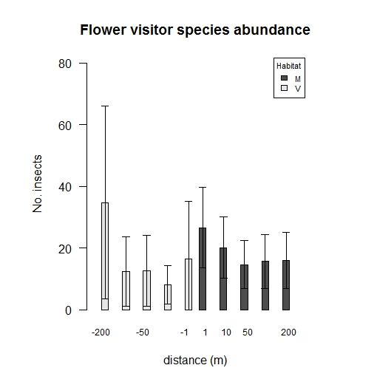

**Figure 1: The influence of distance and habitat on the flower visitor abundance**

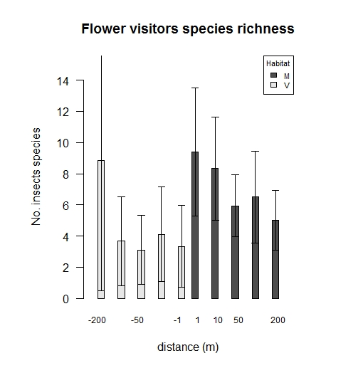

**Figure 2: The influence of distance and habitat on the flower visitor species richness**

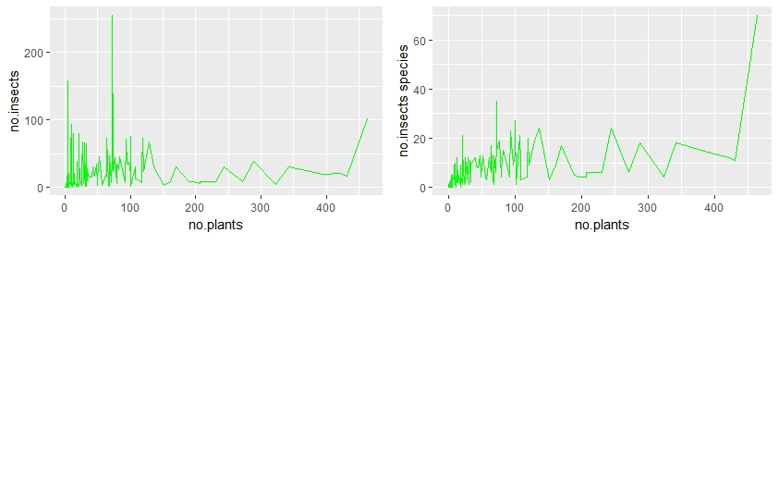

**Figure 3: The influence of plant abundance on the flower visitor abundance and flower visitor species richness**

# Discussion

The results show that habitat, distance and number of plants have an effect on flower visitor abundance and species richness. Both flower visitor abundance and species richness were higher in the mango orchard than the natural vegetation. This pattern may in response to an abundance of mango flowers, as mango flowers are more abundant than most plants. It could also be that most insects prefer plants with more flowers (Carvalheiro et al., 2010).

Flower visitor species richness is influenced by distance from the edge between the two habitats. There is a clear decline in flower visitor abundance and species richness with distance from the edge towards the mango orchard. However, both with flower visitor abundance and species richness with distance from the edge towards the natural vegetation. Species usually move from high to low productivity systems, which means flower visitor are expected to move from the mango orchard into natural vegetation. However, flower visitors were more abundant at the edge between the natural vegetation and the mango orchard. The spill seems to be moving from the edge into the mango orchard.

Flower visitor abundance and species richness increases with an increase in plant abundance. An abundance in plants may attract more and diverse insect flower visitors. This would explain why when there were more plants, there were more flower visitors.

# Conclusion

The results of this study show that mango orchards have more flower visitors than natural vegetation. However, the amount of flowers visitors decreases as one moves further into the orchard. Flower visitor also depend on the abundance of plant.

# References

AIZEN, M. A., & HARDER, L. D. (2009). The Global Stock of Domesticated Honey Bees is Growing Slower Than Agricultural Demand for Pollination. Current Biology. 19, 11.

AIZEN, M. A., GARIBALDI, L. A., CUNNINGHAM, S. A., KLEIN, & A. M. (2009). How much does agriculture depend on pollinators? Lessons from long-term trends in crop production. Ann. Bot. 103, 1579–1588.

AIZEN, M. A, GARIBALDI, L. A, CUNNINGHAM, S. A & KLEIN A. M. (2008). Long-term global trends in crop yield and production reveal no current pollination shortage but increasing pollinator dependency. Current Biology 18, 1572–1575.

BALLY, S. E. (2006). Mangifera indica (mango) Species profiles for pacific island agroforestry. Ver 3.1

KLEIN, A. M., VAISSIE’RE B. E., CANE, J. H., STEFFAN-DEWENTER, I., CUNNINGHAM, S. A., KREMEN, C., & TSCHARNTKE, T. (2007). Importance of pollinators in changing landscapes for world crops. Proceeding of the royal society biology 274, 303–313.

KREMEN, C. (2007). Pollination and other ecosystem services produced by mobile organisms: a conceptual framework for the effects of land-use change. Ecol. Lett. 10, 299–314.

WATSON, L. & DALLWITZ, M. J. (1992). The Families of Flowering Plants: Descriptions, Illustrations, Identification, and Information Retrieval.' Version: 22.

CARVALHEIRO, L. G., SEYMOUR, C.L., VELDTMAN, R. & NICOLSON, S. W. (2010). Pollination services decline with distance from natural habitat even in biodiversity-rich areas. Journal of Applied Ecology, 47, 810–820